**1 、OTA package local upgrade steps**

（1）OTA package named to the update.zip

（2）Copy update.zip to the  TF card or U disk

（3）Inserted U disk or TF card, Will pop up as shown in the figure below, choose Install. It will enter the upgrade process

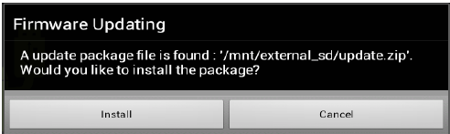

（4）Device reboot into recovery system automatically upgrade. Keep the electricity, Wait for the upgrade is complete, it Will automatically restart into the android home screen.

**2 、OTA packet network upgrade steps**

（1）Server has **OTA** package, device will automatically detect network **OTA** updates, it will Prompt to download upgrades

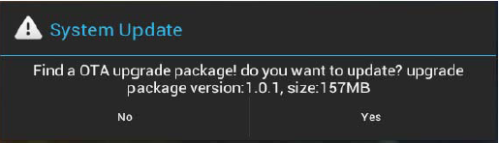

Choose yes，it will download OTA package from network.Don't interrupt it.

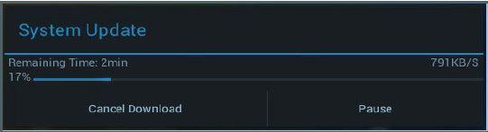

（2）Download completed, Device will reboot into recovery system automatically upgrade. Keep the electricity, Wait for the upgrade is complete, it Will automatically restart into the android home screen.